Voice-Controlled Mechanism

Abstract
The "Voice-controlled mechanism" project presents an innovative approach to human-machine interaction, utilizing voice commands to control physical mechanisms. This project combines Python programming with Arduino hardware, employing the pyfirmata2 library for Arduino communication, speech recognition for voice input processing, and time for task scheduling. The system's core components include an Arduino UNO microcontroller and a servo motor, with programming conducted in the Arduino IDE. By integrating these technologies, this project demonstrates a practical application of voice recognition and servo motor control, showcasing the potential for hands-free and intuitive operation in various fields. The project aims to inspire further exploration and development of voice-controlled systems, highlighting the exciting possibilities of voice-activated mechanisms in modern technology.
Keywords: Voice-controlled mechanism, Python, Arduino, voice recognition

Introduction
In the realm of human-machine interaction, voice control stands as a remarkable frontier, offering hands-free and intuitive operation. The "Voice-controlled mechanism" project exemplifies this advancement by integrating Python programming with Arduino hardware to create a system where verbal commands drive physical actions. This project leverages the pyfirmata2 library for Arduino communication, speech recognition for voice input processing, and time for scheduling tasks, showcasing a synergy of software and hardware.
The core components of this project include an Arduino UNO microcontroller serving as the brain, orchestrating the servo motor's movements in response to voice commands. The Arduino IDE provides the development environment for programming and uploading code to the Arduino board. Through this project, we aim to demonstrate a practical and engaging application of voice recognition and servo motor control, paving the way for more sophisticated voice-controlled systems in various fields.

Technology & Tools
- Python: A high-level programming language used for the development of the project's software components, providing flexibility and ease of use.
- Arduino: An open-source electronics platform used for building the hardware components of the project, offering a simple and accessible approach to microcontroller programming.
- pyfirmata2: A Python library used to communicate with the Arduino board, enabling the control of hardware peripherals and sensors connected to the board.
- Speech recognition: A Python library used for processing voice input, allowing the system to recognize and interpret verbal commands from users.
- time: A Python library used for managing time-related operations in the project, such as scheduling tasks and controlling the timing of actions.
- Arduino UNO: A popular microcontroller board used as the main controller in the project, providing the necessary processing power and I/O capabilities.
- Servo motor: A type of motor used in the project to control the movement of physical mechanisms in response to voice commands.
- Arduino IDE: An integrated development environment used for writing, compiling, and uploading code to the Arduino board, facilitating the programming of the hardware components.

Data Flow Diagram

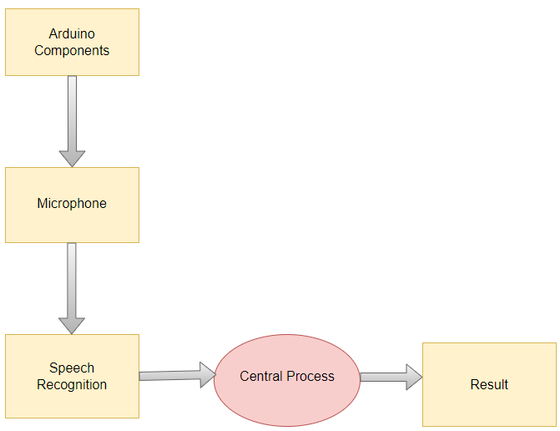
Fig 1.1

Packages Used
- pyfirmata2: Used for communication with the Arduino board, allowing control of hardware peripherals and sensors.
- Speech recognition: Utilized for processing voice input, enabling the system to recognize and interpret verbal commands.
- time: Standard Python library for managing time-related operations, such as scheduling tasks and controlling timing.

Advantages
- Hands-free Operation: Users can interact with the mechanism without the need to physically touch any controls, offering convenience and accessibility.

- Intuitive Interface: Voice commands provide a natural and user-friendly interface, making it easy for users to control the mechanism without prior training.

- Automation: The project can be used to automate various tasks, such as opening doors, turning lights on/off, or controlling robotic arms, enhancing efficiency and convenience.

- Accessibility: Voice control can benefit users with disabilities or mobility issues, allowing them to interact with the mechanism more easily.
- Demonstration of Technology: The project showcases the integration of software (Python) and hardware (Arduino), demonstrating the potential of voice-controlled systems in modern technology.
Applications
- Home Automation: Control home appliances such as lights, fans, and thermostats using voice commands for added convenience and energy efficiency.

- Assistive Technology: Aid individuals with disabilities by enabling them to control devices and appliances using their voice, enhancing their independence and quality of life.

- Industrial Automation: Implement voice-controlled mechanisms in manufacturing processes for tasks such as material handling, assembly, and quality control.

- Security Systems: Integrate voice recognition into security systems for access control, allowing authorized personnel to enter secure areas using voice commands.

- Entertainment Systems: Control entertainment devices such as TVs, audio systems, and gaming consoles using voice commands for a hands-free experience.

- Education and Training: Use voice-controlled mechanisms in educational settings to teach programming, electronics, and system integration concepts.

Future Scope
- Enhanced Voice Recognition: Integration of advanced natural language processing (NLP) techniques to improve the accuracy and responsiveness of voice commands.

- Integration with AI and ML: Incorporation of artificial intelligence (AI) and machine learning (ML) algorithms to enable the system to learn and adapt to users' preferences and behavior over time.

- Expansion of Use Cases: Exploration of new use cases and applications in areas such as healthcare, education, and retail, expanding the reach and impact of voice-controlled mechanisms.

- Interoperability and Connectivity: Integration with other smart devices and platforms to enable seamless communication and interaction in smart home and IoT environments.

- Accessibility Features: Development of features to cater to users with specific needs, such as multi-language support, voice recognition for individuals with speech impairments, and personalized user profiles.

Conclusion
In summary, the "Voice-controlled mechanism" project exemplifies a seamless fusion of Python programming and Arduino hardware, showcasing the practicality and potential of voice-activated systems. By leveraging the pyfirmata2 and speech recognition libraries, alongside the Arduino UNO microcontroller and servo motor, this project offers a hands-free and intuitive interface for controlling physical mechanisms. Its applications span across diverse fields, including home and industrial automation, with future prospects in enhanced voice recognition, AI integration, and expanded use cases. Overall, this project serves as a testament to the innovative strides in human-machine interaction, paving the way for smarter and more accessible technology solutions.

